Idea Outline
Project Title: The Urban Gala

Problem
Navigating New York City’s nightlife can be overwhelming - users are often faced with too many choices, and a lack of real-time, personalised recommendations. Whether you’re in the mood for a cozy jazz bar, or an energetic rooftop club, it’s hard to know where to go, when to go and what the vibe will be.

Our Goal
Our project aims to build a responsive web app that helps users make smarter decisions when choosing a night out.

Concept
Users describe the kind of experience they want (e.g. “packed techno club”, “laid-back cocktail lounge”), and our AI model will recommend a matching venue. Users can then select to be given routing directions to a venue.
A live map lets users explore venue details, see current busyness and the vibe of the venue, and plan a route.
We will have a “What’s Hot?” sections, providing details of the busiest venues, in real time.

Key Features:
- AI-powered Vibe matching - users input mood/ preferences, get a personalised venue suggestion
- Interactive Map view - clickable venues, showing live details, crowd info, vibe
- What’s Hot - highlights busiest venues right now
- User login

We want to help users discover their perfect night out, showcasing how crowd data, LLMs and thoughtful UI can solve a real urban problem.

Datasets
- Yellow Taxi
- Uber/Lyft
- Metro Turnstyle
- Bike
- Public Holiday
- Weather
- Build our own dataset - Bots and Google API to create POIs
- Foot Fall API
- Twitter/Reddit Bots

Stress Test

Looking for a category that does not exist
Scenario: A user searches for a venue type or “vibe” that doesn’t exist (e.g. “underwater night club”)
Response: Ensure graceful fallback - display a friendly “no results” message, with suggestions for similar categories

Scroll outside of Manhattan on the Map
Scenario: User scrolls outside of Manhattan
Response: Limit the map view, for only Manhattan

Website Link does not exist (for user search)
Scenario: A venue’s website link is no longer active
Response: Display a “link unavailable” message

Website Link does not exist (for scraping)
Scenario: Scraping fails due to a venue’s website changing format/ offline
Response: Implement fallback logic
User tries to save many POIs into favourite’s (need a limit)
Scenario: User tries to save hundreds of venues to favourites
Response: Set a limit (e.g. 20 favourites), and prompt the user to remove others if they exceed it

User tries to use app offline or loses connection
Scenario: User loses internet connection mid-session
Response: Cache essential content, and display an offline message

LLM Misunderstanding or Hallucinations
Scenario: The AI suggest a venue that doesn’t exist, or is unrelated to the user’s prompt.
Response: Include fallback filtering, based on location, category, vibe

SWOT
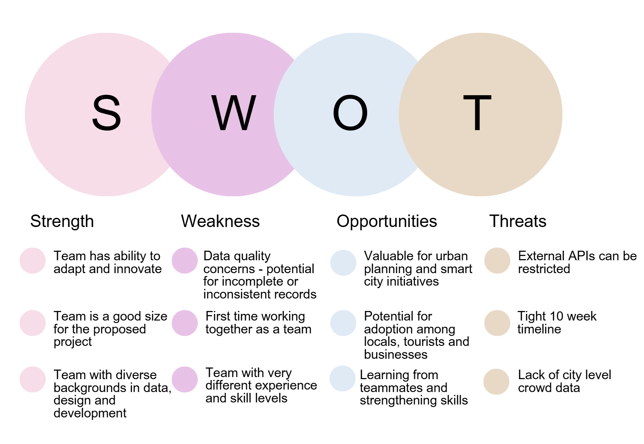

Questions

- Anything more we need to consider in terms of the stress test
- How will the final demo work?
- Are our described roles flexible?

